L04: Homework Assignment

Instructions: You are encouraged to collaborate with other students on the homework, but it is important that you do your own work. Before working with someone else on the assignment, you should attempt each problem on your own.

- In your own words, list the three rules of probability.

A class survey in a statistics class asked students to list which state they were from. The results of the survey are given in the following table.

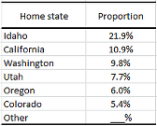

Use this information to answer questions 2 through 6.

- One of the probabilities is missing from the table. What should that missing probability be, if the table is supposed to be a probability distribution? Which rule of probability helped you answer this question?

- Randomly select a student in the class. According to the table, what is the probability of selecting a student that is from Washington or Oregon?

- Randomly select a student in the class. According to the table, what is the probability of selecting a student that is not from Idaho? Which rule of probability helped you answer this question?

- Randomly select a student in the class. According to the table, what is the probability of selecting a student that is not from Utah or California?

- Randomly select a student in the class. According to the table, what is the probability of selecting a student that is from Texas?

In the finance industry, investors make decisions based on past and present performance of the market. A stock is a share in the ownership of a company. For example, if you were to purchase stock in McDonald's, you would own a small part of that company. If the company does well in the future, the value of your stock would be expected to rise. Then, you could sell your shares in the company for a profit. Stocks are sold in a stock market.

Using historical data, a market analyst forecasts that the probability is 0.30 that the value of McDonald’s stock will go up by 60% in the next year. The analyst calculates that the probability that the stock will increase by 15% is 0.31. Some of the analyst’s other forecasts are summarized in the table below:
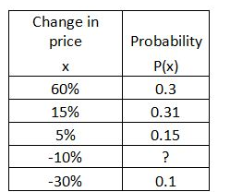

- Use the information in the table above to determine the probability that McDonald’s stock will go down by 10% over the next year.

- Using the information in the table, determine the probability that McDonald’s stock will go up by less than 16% over the next year.

- Using the information in the table, determine the probability that McDonald’s stock will go up by exactly 10% over the next year.

- You are thinking about investing in McDonald’s stock. Is the value more likely to go up or go down over the next year?

